**João Vitor Sanches 9833704**

Em conjunto com Victor Chacon Codesseira 9833711

**Aula 5 – Análise Modal**

Com a estrutura já modelada e as matrizes calculadas, az sentido completar o programa existente para o cálculo das frequências naturais. Para fins de comparação, analisou-se uma viga de seção quadrada com 1m x 0.05m x 0.05m, engastada em sua extremidade. O estudo foi feito com o programa desenvolvido (variado a quantidade de elementos), analiticamente e com um software comercial de elementos finitos. Os resultados são apresentados na tabela a seguir:

|  |  |  |  |  |
| --- | --- | --- | --- | --- |
| **Método** | | **Modo de vibrar** (freqs. em Hz) | | |
| 1o | 2o | 3o |
|  | Analítico | 40.90 | 256.34 | 722.42 |
| Solidworks | Sólido 3D | 42.88 | 256.47 | 729.56 |
| Elemento de Viga | 40.67 | 253.39 | 702.92 |
| Programa | 1 elemento | 41.1 | 405.05 | 1396 |
| 2 elementos | 40.93 | 258.53 | 874.39 |
| 3 elementos | 40.91 | 257.19 | 726.74 |
| 1000 elementos | 40.91 | 256.34 | 717.81 |

Analiticamente, as frequências (em rad/s) foram obtidas com:

$$ω_{n1}= α^{2} \sqrt{\frac{E I}{ρ A L^{4}}}$$

Com $α = 1.875; α = 4.694; α = 7.88$

Com o Solidworks, a estrutura em questão foi modelada e simulada, tanto com elementos de viga como com elementos tridimensionais. Algumas imagens do resultado são apresentadas abaixo:

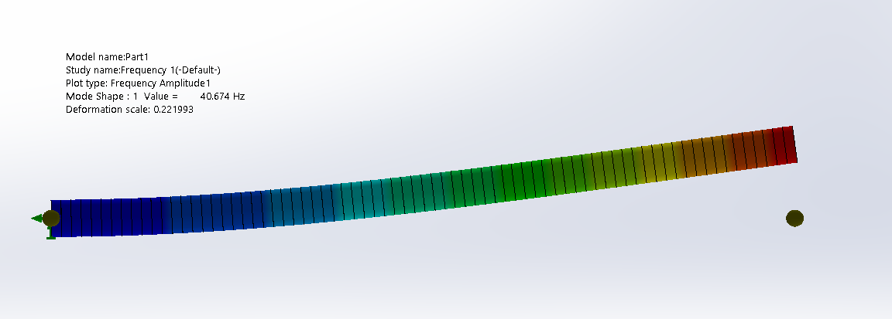

(Simulação com elementos de viga. Primeiro modo de vibrar)

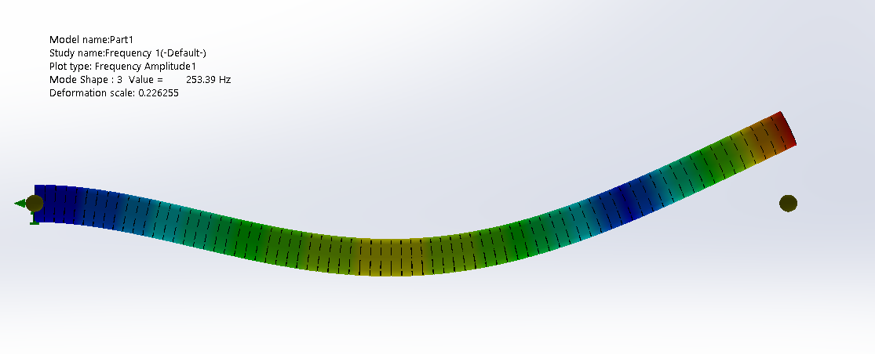

(Simulação com elementos de viga. Segundo modo de vibrar)

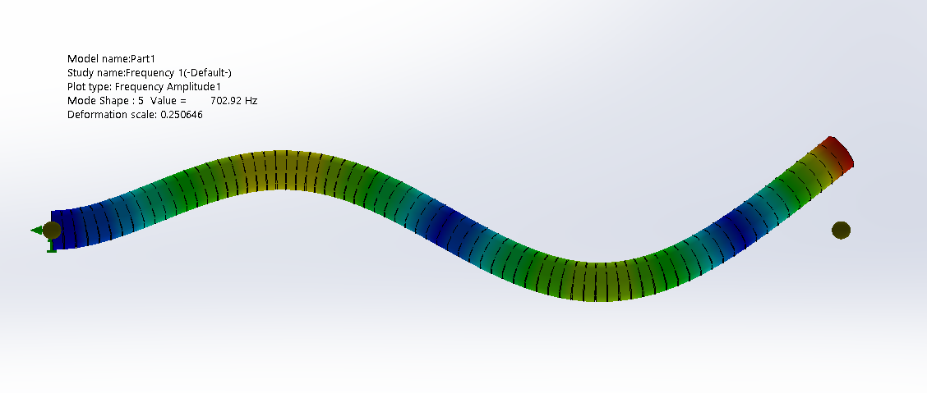

(Simulação com elementos de viga. Terceiro modo de vibrar)

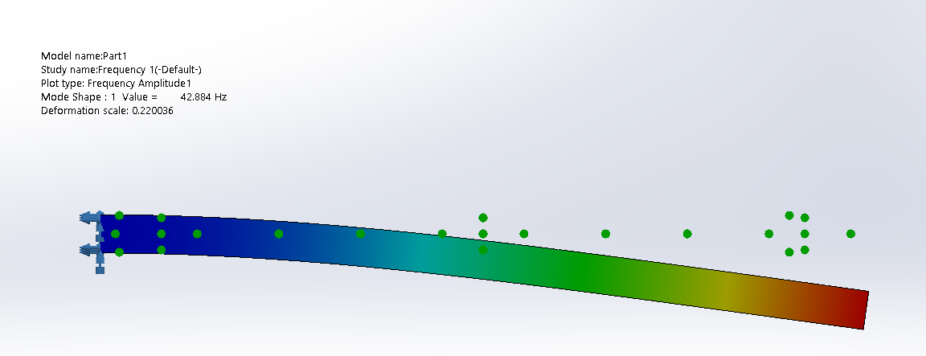

(Simulação com elementos tridimensionais. Primeiro modo de vibrar)

Para o uso do programa desenvolvido, algumas alterações foram feitas de modo que a execução de simulações com mais elementos fosse mais rápida. O programa completo está disponível em <https://github.com/jvSanches/PMR5026>. Algumas seções estão listadas abaixo:

**Cantiliever_beam_modal.py**

Esse programa foi utilizado para criar arquivos de entrada com vários elementos para a análise modal

import time

import subprocess

import os

# Propriedades da viga

E = 200e9

A = 0.0025

I = 5.21e-7

p = 7800

# Número total de elementos

n_el = int(input("Digite a quantidade de elementos: "))

if n_el < 1:

    raise AttributeError

print("\nStarting file assembly")

start_time = time.time()

# Criando arquvio de entrada

filename = f"balanco_modal_{n_el}.txt"

with open(filename, 'w') as f:

    f.write("#HEADER\n")

    f.write(f"Analise modal de viga em balanco com {n_el} elemento(s)\n")

    f.write("\n#MODAL\n")

    f.write("1\n")

    f.write("\n#NODES\n")

    for x in range(0, n_el+1):

        f.write(f"{x/n_el} 0\n")

    f.write("\n#ELEMENTS\n")

    for x in range(1, n_el+1):

        f.write(f"b {x} {x+1} {A} {E} {I} {p}\n")

    f.write("\n#CONSTRAINTS\n")

    f.write("@1\n")

    f.write("0 0 0\n\n")

middle_time = time.time()

print(f"Took {middle_time - start_time} seconds\n")

print("Starting matlab job")

# Rodando matlab

subprocess.run(["matlab", "-batch", f"mefController('{filename}')"])

print(f"\nTook {time.time() - middle_time} seconds")

# Deletando arquivo gerado

os.remove(filename)

input()

**loader.m**

%% Open and read the file

disp("Reading file")

fid = fopen(filename);

Text = textscan(fid,'%s','delimiter','\n');

Text = Text{1};

fclose(fid);

disp("Interpreting file")

header_lines =[];

dynamic_mode = 0;

modal_analysis = 0;

nodes = [];

elements = [];

reading_load_on_node = 0;

reading_load_on_element = 0;

reading_constrain_on_node = 0;

reading_disp_on_node = 0;

reading_vel_on_node = 0;

reading_acc_on_node = 0;

part_load_data = [];

initial_disp = [];

initial_vel = [];

initial_acc = [];

state = "";

for i = 1:length(Text)

line = Text{i};

if isempty(line)

if reading_load_on_node

nodes(reading_load_on_node).setLoad(part_load_data(:,1),part_load_data(:,2),part_load_data(:,3));

reading_load_on_node = 0;

end

if reading_load_on_element

elements(reading_load_on_element).setPressure(part_load_data(:,1),part_load_data(:,2));

reading_load_on_element = 0;

end

if reading_constrain_on_node

nodes(reading_constrain_on_node).constrain(constrain_data(1),constrain_data(2),constrain_data(3));

reading_constrain_on_node = 0;

end

if reading_disp_on_node

initial_disp(:,reading_disp_on_node) = transpose(disp_data);

reading_disp_on_node = 0;

end

if reading_vel_on_node

initial_vel(:,reading_vel_on_node) = transpose(disp_data);

reading_vel_on_node = 0;

end

if reading_acc_on_node

initial_acc(:,reading_acc_on_node) = transpose(disp_data);

reading_acc_on_node = 0;

end

state = "";

continue;

elseif line(1) == "#"

state = line;

continue;

end

switch state

case "#HEADER"

header_lines = [header_lines line newline];

case "#DYNAMIC"

dynamic_mode = sscanf(line, '%i') == 1;

timestep = 0;

simtime = 0;

case "#MODAL"

modal_analysis = sscanf(line, '%i') == 1;

case '#TIMESTEP'

timestep = sscanf(line, '%f');

case '#SIMTIME'

simtime = sscanf(line, '%f');

case '#NODES'

a = sscanf(line, '%f %f', [1 2]);

new_node = node(a(1), a(2));

nodes = [nodes new_node];

new_node.setIndex(length(nodes));

case '#ELEMENTS'

a = sscanf(line, '%s %f %f %f %f %f %f', [1 7]);

if a(1) == 't'

new_element = truss(nodes(a(2)), nodes(a(3)), a(4), a(5), a(6));

elseif a(1) == 'b'

new_element = beam(nodes(a(2)), nodes(a(3)), a(4), a(5), a(6), a(7));

end

elements = [elements new_element];

case '#LOADS'

if a(1)=='@'

if reading_load_on_node

nodes(reading_load_on_node).setLoad(part_load_data(:,1),part_load_data(:,2),part_load_data(:,3));

end

reading_load_on_node = str2num(a(2:end));

else

a = sscanf(line, '%f %f %f', [1 3]);

part_load_data = [part_load_data ; a];

end

case '#PRESSURES'

if line(1)=='@'

if reading_load_on_element

elements(reading_load_on_element).setPressure(part_load_data(:,1),part_load_data(:,2));

end

reading_load_on_element = str2num(line(2:end));

else

a = sscanf(line, '%f %f %f', [1 3]);

part_load_data = [part_load_data ; a];

end

case '#CONSTRAINTS'

if line(1)=='@'

if reading_constrain_on_node

nodes(reading_constrain_on_node).constrain(constrain_data(1),constrain_data(2),constrain_data(3));

end

reading_constrain_on_node = str2num(line(2:end));

else

constrain_data = sscanf(line, '%s %s %s', [1 3]);

end

case '#INITIALDISP'

if initial_disp.isempty

initial_disp = zeros(2,length(nodes));

end

if line(1)=='@'

if reading_disp_on_node

initial_disp(:,reading_disp_on_node) = transpose(disp_data);

end

reading_disp_on_node = str2num(line(2:end));

else

disp_data = sscanf(line, '%s %s %s', [1 3]);

end

case '#INITIALVEL'

if initial_vel.isempty

initial_vel = zeros(2,length(nodes));

end

if line(1)=='@'

if reading_vel_on_node

initial_vel(:,reading_vel_on_node) = transpose(vel_data);

end

reading_vel_on_node = str2num(line(2:end));

else

vel_data = sscanf(line, '%s %s %s', [1 3]);

end

case '#INITIALACCEL'

if initial_acc.isempty

initial_acc = zeros(2,length(nodes));

end

if line(1)=='@'

if reading_acc_on_node

initial_acc(:,reading_acc_on_node) = transpose(acc_data);

end

reading_acc_on_node = str2num(line(2:end));

else

disp_acc = sscanf(line, '%s %s %s', [1 3]);

end

end

end

%% Display loaded info

%clc

disp([filename ' loaded'])

disp('----------------------------------------------------')

disp(header_lines)

disp('----------------------------------------------------')

disp([num2str(length(nodes)) ' nodes ' ])

disp([num2str(length(elements)) ' elements ' ])

disp('Loading Done');

%% Clear workspace

clear ans a fid filename header_lines i j new_element new_node part_load_data reading_load_on_element reading_load_on_node reading_on_node Text

**preProcessor.m**

disp('Building global stiffness matrix...');

Kglobal = sparse(3*length(nodes), 3*length(nodes));

for i=1:length(elements)

[k11, k12, k22, index1, index2] = elements(i).decomposeStiffnes();

k21 = transpose(k12);

index1 = 3 * (index1 - 1);

index2 = 3 * (index2 - 1);

for j = 1:3

for k = 1:3

Kglobal(index1 + j, index1 + k) = Kglobal(index1 + j, index1 + k) + k11(j, k);

Kglobal(index1 + j, index2 + k) = Kglobal(index1 + j, index2 + k) + k12(j, k);

Kglobal(index2 + j, index1 + k) = Kglobal(index2 + j, index1 + k) + k21(j, k);

Kglobal(index2 + j, index2 + k) = Kglobal(index2 + j, index2 + k) + k22(j, k);

end

end

end

disp('Done')

if modal_analysis

disp('Building global mass matrix...');

Mglobal = sparse(3*length(nodes), 3*length(nodes));

for i=1:length(elements)

[m11, m12, m22, index1, index2] = elements(i).decomposeMass();

m21 = transpose(m12);

index1 = 3 * (index1 - 1);

index2 = 3 * (index2 - 1);

for j = 1:3

for k = 1:3

Mglobal(index1 + j, index1 + k) = Mglobal(index1 + j, index1 + k) + m11(j, k);

Mglobal(index1 + j, index2 + k) = Mglobal(index1 + j, index2 + k) + m12(j, k);

Mglobal(index2 + j, index1 + k) = Mglobal(index2 + j, index1 + k) + m21(j,k);

Mglobal(index2 + j, index2 + k) = Mglobal(index2 + j, index2 + k) + m22(j,k);

end

end

end

disp('Done')

end

F = sparse(length(nodes),1);

for i=1:length(nodes)

F(3*i - 2) = nodes(i).fx;

F(3*i-1) = nodes(i).fy;

F(3*i) = nodes(i).mo;

end

clear i index1 index2 k11 k12 k21 k22 m11 m12 m21 m22 Kdist Mdist

**solver.m**

disp('Starting Solver')

%% Reduces system with given constraits

for i=1:length(nodes)

if nodes(i).xconstrained

for j = 1:length(Kglobal)

F(j) = F(j) - Kglobal(j,3*i-2) * nodes(i).dx;

Kglobal(3*i-2,j) = 0;

Kglobal(j,3*i-2) = 0;

end

F(3*i-2) = nodes(i).dx;

Kglobal(3*i-2, 3*i-2) = 1;

end

if nodes(i).yconstrained

for j = 1:length(Kglobal)

F(j) = F(j) - Kglobal(j,3*i-1) * nodes(i).dy;

Kglobal(3*i-1,j) = 0;

Kglobal(j,3*i-1) = 0;

end

F(3*i-1) = nodes(i).dy;

Kglobal(3*i-1, 3*i-1) = 1;

end

if nodes(i).thetaconstrained

for j = 1:length(Kglobal)

F(j) = F(j) - Kglobal(j,3*i) * nodes(i).dtheta;

Kglobal(3*i,j) = 0;

Kglobal(j,3*i) = 0;

end

F(3*i) = nodes(i).dtheta;

Kglobal(3*i, 3*i) = 1;

end

end

if modal_analysis

for i=1:length(nodes)

if nodes(i).xconstrained

for j = 1:length(Mglobal)

Mglobal(3*i-2,j) = 0;

Mglobal(j,3*i-2) = 0;

end

Mglobal(3*i-2, 3*i-2) = 1;

end

if nodes(i).yconstrained

for j = 1:length(Mglobal)

Mglobal(3*i-1,j) = 0;

Mglobal(j,3*i-1) = 0;

end

Mglobal(3*i-1, 3*i-1) = 1;

end

if nodes(i).thetaconstrained

for j = 1:length(Mglobal)

Mglobal(3*i,j) = 0;

Mglobal(j,3*i) = 0;

end

Mglobal(3*i, 3*i) = 1;

end

end

return

end

D = linsolve(full(Kglobal),full(F));

for i=1:length(nodes)

nodes(i).dx = D(3*i-2);

nodes(i).dy = D(3*i-1);

nodes(i).dtheta = D(3*i);

end

clear i j

**postProcessor.m**

scale_deform = 100;

scale_normal = 5e-6;

scale_shear = 4e-6;

scale_moment = 5e-6;

disp("Calculating results...");

if modal_analysis

v = eigs(Mglobal\Kglobal, 9, 0, 'maxit', 1e12);

v = sqrt(v)/(2*pi);

v = sort(v);

v = v(4:9);

disp("Vibrating modes(Hz)")

disp(num2str(v,8));

return

end

scatterNodes(nodes, elements, false, true, 0);

title("Não deformado")

fig_u = scatterNodes(nodes, elements, true, false, scale_deform);

title("Deslocamentos")

for i = 1:length(nodes)

txt = sprintf("dx: %f\ndy: %f\ndr: %f", [nodes(i).dx, nodes(i).dy, nodes(i).dtheta]);

text(nodes(i).x + nodes(i).dx*scale_deform - 0.4, nodes(i).y + nodes(i).dy*scale_deform + 0.3, txt);

end

fig_N = scatterNodes(nodes, elements, false, true, 0);

title("Normal")

fig_V = scatterNodes(nodes, elements, false, true, 0);

title("Cortante")

fig_M = scatterNodes(nodes, elements, false, true, 0);

title("Momento fletor")

for i=1:length(elements)

elements(i) = elements(i).calculateStress();

el = elements(i);

x = linspace(0, el.L, 101);

T = [el.l, el.m; -el.m, el.l]^-1;

%% Display displacement

figure(fig_u)

u = x + scale_deform*(eval(subs(el.elasticLineX))-x);

v = scale_deform*(eval(subs(el.elasticLineY)));

points = T*[u;v] + [el.n1.x; el.n1.y];

plot(points(1,:), points(2,:), 'Color', [0 0.447 0.741]);

%% Display normal

plotDiagram(fig_N, el, el.Normal, x, T, scale_normal);

%% Display shear

plotDiagram(fig_V, el, el.Shear, x, T, scale_shear);

%% Display moment

plotDiagram(fig_M, el, el.Moment, x, T, scale_moment);

end

%% Function for scatter of nodes

function fig = scatterNodes(nodes, elements, displaced, lines, scale)

fig = figure();

hold on;

grid on;

max_x = -inf;

min_x = inf;

max_y = -inf;

min_y = inf;

for i=1:length(nodes)

nx = nodes(i).x;

ny = nodes(i).y;

if displaced

nx = nx + scale*nodes(i).dx;

ny = ny + scale*nodes(i).dy;

end

max_x = max(max_x, nx);

max_y = max(max_y, ny);

min_x = min(min_x, nx);

min_y = min(min_y, ny);

if nodes(i).xconstrained

if nodes(i).yconstrained

scatter(nx, ny, 's', 'filled', 'red');

else

scatter(nx, ny, '>', 'filled', 'red');

end

else

if nodes(i).yconstrained

scatter(nx, ny,'^' ,'red');

else

scatter(nx, ny, 'red');

end

end

end

offset = 1;

axis equal

axis([min_x-offset max_x+offset min_y-offset max_y+offset])

if lines

for i=1:length(elements)

if displaced

line_x = [elements(i).n1.x+scale*elements(i).n1.dx, elements(i).n2.x+scale*elements(i).n2.dx];

line_y = [elements(i).n1.y+scale*elements(i).n1.dy, elements(i).n2.y+scale*elements(i).n2.dy];

else

line_x = [elements(i).n1.x, elements(i).n2.x];

line_y = [elements(i).n1.y, elements(i).n2.y];

end

line(line_x,line_y)

end

end

end

function plotDiagram(fig, element, equation, divisions, rot, scale)

offset_x = -0.15;

offset_y = 0.05;

figure(fig);

syms x

if (isnumeric(equation) && abs(equation) < 1e-6) || (~isnumeric(equation) && isnumeric(eval(equation)) && abs(eval(equation)) < 1e-6)

return

end

data = eval(subs(equation, x, divisions));

if abs(data) < 1e-6

return

end

points = rot*[divisions;scale*data] + [element.n1.x; element.n1.y];

plot(points(1,:), points(2,:), 'r');

line([points(1,1), element.n1.x], [points(2,1), element.n1.y], 'Color', 'r');

line([points(1,end), element.n2.x], [points(2,end), element.n2.y], 'Color', 'r');

text(points(1,1) + offset_x, points(2,1) + offset_y, string(data(1)));

text(points(1,end) + offset_x, points(2,end) + offset_y, string(data(end)));

end

**mefController.m**

function mefController(filename)

close all

if nargin < 1

filename = "balanco_modal_1.txt";

end

run loader.m

%run plotter.m

if dynamic_mode

run dynamicPreProcessor.m

run dynamicSolver.m

%run dynamicPlotter.m

else

run preProcessor.m

run solver.m

%run plotter.m

run postProcessor.m

end

end